11 I Need to ESCAPE
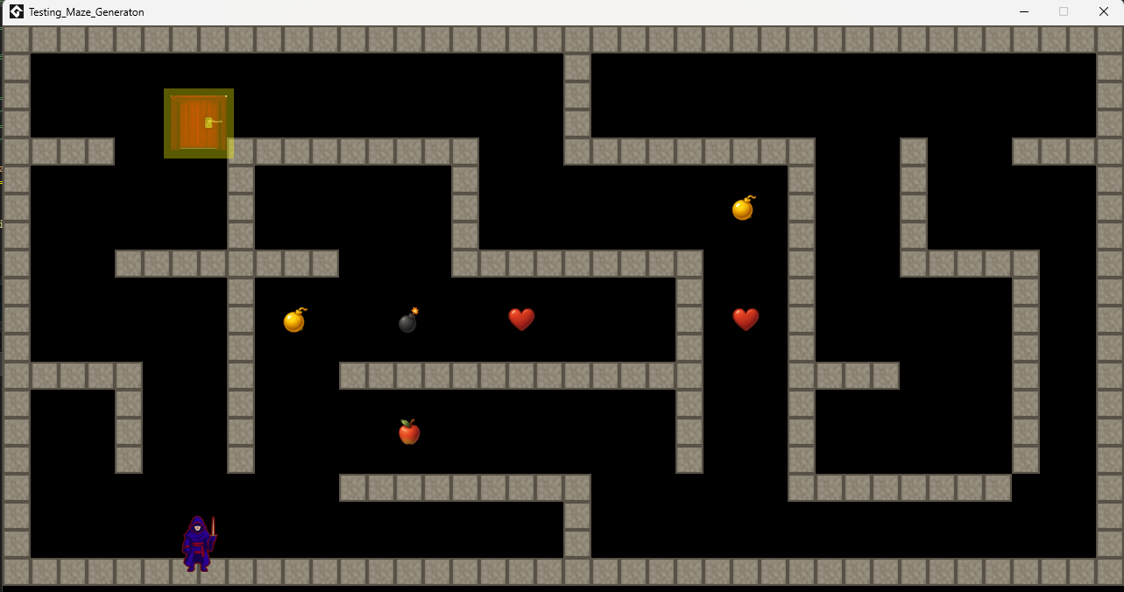
Some times for no apparent reason the game might glitch and trap the player with no way to get out. Above you can see that the hero object spawned it self into a wall, and he can not move.

